Klasterisasi dan Geovisualisasi *Tweet* Penyebaran Penyakit Menular Langsung (Studi Kasus COVID-19)

**Fahmirullah Abdillah 1)[1] , Ira Puspitasari 2)** **, Eto Wuryanto3)**

1)2)3) Information Systems, Faculty of Science and Technology, Universitas Airlangga, IndonesiaJl. Dr. Ir. H. Soekarno, Mulyorejo, Surabaya

1) fahmirullah.abdillah-2018@fst.unair.ac.id, 2)ira-p@fst.unair.ac.id, 3) eto-w@fst.unair.ac.id

|  |
| --- |
| *Abstract*  **Background:** Layanan media sosial *microblog* seperti Twitter menghasilkan aliran besar dalam penyebaran informasi terhadap suatu kejadian. Media sosial dimanfaatkan sebagai bentuk pengawasan penyebaran penyakit menular langsung.  **Objective:** Penelitian ini bertujuan untuk menerapkan algoritma *clustering* berbasis kepadatan, algoritma DBSCAN dan OPTICS.  **Methods:** How did you go about finding it? What type of methodology did you use? A quantitative study/a randomized controlled study/a qualitative survey/a literature review/a double blind trial  **Results:** What did you find? What data or outcomes did you observe? Do not be vague! State exactly what you found.  **Conclusion:** What did your results tell you? Did you find out what you wanted? Why or why not? What should be studied next?  (Abstract consists of 150 to a maximum of 300 words. Abstracts are arranged in a structured manner.)  ***Keywords:***Twitter, *Preprocessing*, *Clustering*, DBSCAN, OPTICS, *Density-based Algorithm*, *silhouette coefficient*.  ***Article history:***Received 5 April 20XX, first decision 22 April 20XX, accepted 22 August 20XX, available online 28 October 20XX |

Introduction

This template provides authors with most of the formatting specifications needed for preparing electronic versions of their papers for *Journal of Information Systems Engineering and Business Intelligence*. All standard paper components have been specified for three reasons: (1) ease of use when formatting individual papers, (2) automatic compliance to electronic requirements that facilitate the concurrent or later production of electronic products, and (3) conformity of style throughout a journal publication. Generally, a typical paper contains between 3000 and 6000 words, but there are no rigorous restrictions. Margins, column widths, line spacing, and type styles are built-in; examples of the type styles are provided throughout this document. Manuscripts must be structured using the IMRaD (Introduction, Method, Results, Discussion, and Conclusion) format. Introduction, Method, Results, Discussion, and Conclusion should be organized into separate sections. If considered necessary, you can add a Literature review section before the Method section

Authors should be aware that they are addressing an international audience. The manuscript must be arranged to highlight the novelty and contributions that the global community can adopt. If your study uses case studies, make sure that the case studies are not the focus of the novelty/contribution but as a data source. The authors can explain the use of a case study as the data source in the methods section; please avoid writing this in the title or introduction section.

Manuscripts must be submitted in grammatically correct English using standard American English for the benefit of the readers, reviewers, and editors. per our policies, to improve the quality of journal articles, we require authors to perform English editing (proofreading) services with our partner(s) if the paper is accepted for publication.

The introduction must explain the context/object of research and why this research is important. It must focus in accordance with the scope of the title. Authors must include the existing research gap, explaining the unique differences from this study compared to similar previous studies. Authors should cite at least six recent papers closely related to the title of the paper to show the research gap. The research objectives/contributions of the manuscript must be written explicitly.

Literature Review

Related Works or Literature review section is optional. This section may only be available if the explanation related to previous research is not sufficient if it is only shown in the introduction. A literature review is a critical, analytical summary and synthesis of the current knowledge of a topic. It should compare and relate different theories, findings, and so on, rather than just summarize them individually. It should also have a particular focus or theme to organize the review. The length of this section commonly is between 300 – 600 words.

Use sub-heading accordingly, the maximum depth of the subheading is Subheading 3. Please Use the Microsoft Word template style included in template, e.g.: JISEBI Author Name, JISEBI Abstract text, JISEBI Heading 1, etc. All Style for manuscript layout is available in this template.

Subheading 2

Example of Subheading 2.

Subheading 3

Example of Subheading 3. This is the maximum depth of the subheading. Please avoid using bullets and numbering in the manuscript.

Methods

The methods sections often come disguised with other article-specific section titles, but serve a unified purpose: to detail the methods used in an objective manner without introduction of interpretation or opinion. The methods sections should tell the reader clearly how the results were obtained. In addition, the procedure must be written chronologically and clearly. They should be specific. They should also make adequate reference to accepted methods and identify differences. In the method section, authors are recommended to cite a source who helped in the selection of the method. Authors are expected to describe how results will be measured, tested, and evaluated.

Figure

All figures should be numbered with Arabic numerals (1,2,3,….). Every figure should have a caption. All photographs, schemas, graphs and diagrams are to be referred to as figures. Line drawings should be good quality scans or true electronic output. Low-quality scans are not acceptable. Figures must be embedded into the text and not supplied separately. In MS word input the figures must be properly coded. Lettering and symbols should be clearly defined either in the caption or in a legend provided as part of the figure. Figures should be placed as close as possible to the first reference to them in the paper. The allowed figure forms are picture, vector, and graphic.

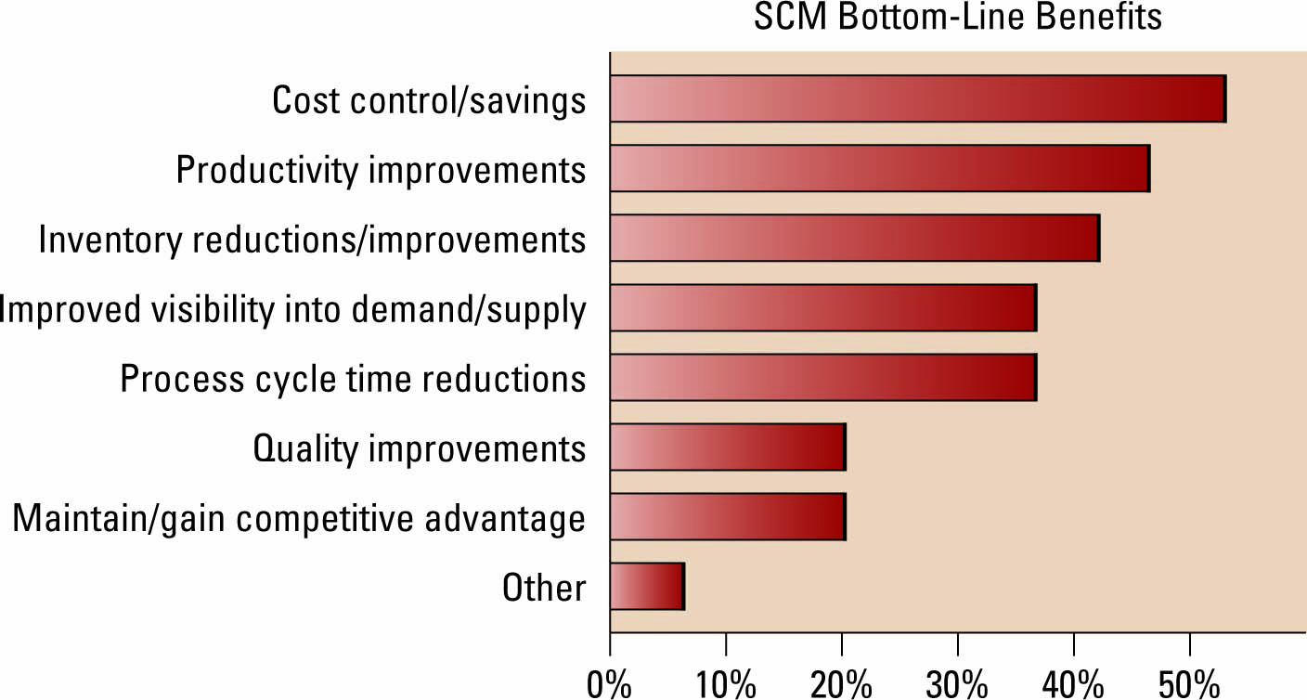

Fig. 1 Figure captions should be standalone. Descriptive enough to be understood without having to refer to the main text.

Picture

Preferred format of figures/images are PNG, and JPEG. Please ensure that all the figures are of 330 PPI resolutions as this will facilitate good output. Please ensure that the resolutions in images in word documents are at least in HD (330 ppi: good quality for high-definition displays). Please click on photos and choose “Picture Format” 🡪 “Compress Pictures” 🡪 “Resolution options” to facilitate this requirement.

The figure number and caption should be typed below the illustration in 8 pt and left justified [Note: one-line captions of length less than column width (or full typesetting width or oblong) centered]. Artwork has no text along the side of it in the main body of the text. For example, see Fig. 1.

Vector

Suppose the figures come from a vector drawing app, for example, Visio, Inkscape, Diagrams.net, or other similar applications. In that case, it is better if the figure files in vector format are embedded directly into the manuscript without being converted to pictures. So, the quality of the figure resolution can be maintained. Usually, this format is suitable for describing research procedures in the methods section. For example, see Fig. 2.

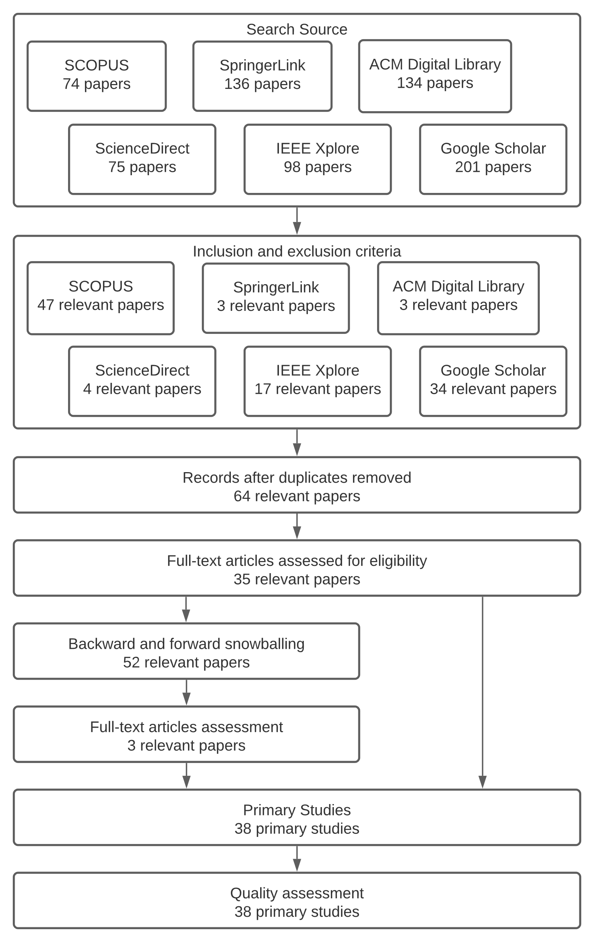

Fig. 2 Study search and selection process.

Graphic

The same happens if the figures are a graphic made using Microsoft Office. It is perfect if you embed the graph directly into Word so that the resolution quality of the figure remains at its best. Make sure all labels are visible in the document. Please remove the outline lines for the best appearance.

If figures have the same context, they should be placed next to each other and grouped into one caption. For example, see Fig. 3.

|  |  |
| --- | --- |
| (a) | (b) |
| (c) | (d) |
| Fig. 3 Respondent profiles differentiated based on (a) Age; (b) Occupation; (c) Gender; (d) District | |

## Table

All tables should be numbered with Arabic numerals. Every table should have a caption. Headings should be placed above tables, left justified. Only horizontal lines should be used within a table, to distinguish the column headings from the body of the table, and immediately above and below the table. Tables must be embedded into the text and not supplied separately. Table 1 is an example which the authors may find useful.

TABLE 1

The significance of The Relationships in The Model

|  |  |  |  |  |  |
| --- | --- | --- | --- | --- | --- |
| Relationships | Original Sample (O) | Sample Mean (M) | Standard Deviation (STDEV) | T Statistics (|O/STDEV|) | P Values* |
| Perceive Ease of Use ->Attitude | 0.286 | 0.288 | 0.058 | 4.907 | 0.000 |
| Information Quality ->Intention to Use | 0.175 | 0.174 | 0.072 | 2.434 | 0.015 |
| Intention to Use ->Use | 0.657 | 0.658 | 0.039 | 17.054 | 0.000 |
| Use ->Net Benefits | 0.463 | 0.461 | 0.061 | 7.576 | 0.000 |
| Use ->User Satisfaction | 0.405 | 0.400 | 0.068 | 5.936 | 0.000 |
| Performance Expectancy -> Intention to Use | 0.052 | 0.053 | 0.058 | 0.893 | 0.372 |
| User Satisfaction ->Net Benefits | 0.428 | 0.430 | 0.059 | 7.207 | 0.000 |

*alpha=0.05 (this is additional legend/caption for clarity of data description, if needed)

## Algorithm

Pseudocode, or structured English, allows a programmer to use English-like sentences to write an explanation of what a program is supposed to do. An example of pseudocode can be seen in Algorithm 1.

**Algorithm 1**

Person identification

***function*** *person_identification ()*

***get*** *subject and object token*

***for each*** *subject and object token*

***set*** *token as person*

***end for***

***return*** *person*

Equations

Equations and formulae should be typed in Mathtype or any Equation Editor, and numbered consecutively with Arabic numerals in parentheses on the right hand side of the page (if referred to explicitly in the text). They should also be separated from the surrounding text by one space.

       

Be sure that the symbols in your equation have been defined before or immediately following the equation. Use “(1),” not “Eq. (1)” or “equation (1),” except at the beginning of a sentence: “Equation (1) is ...”

Results

The results section and the following discussion section allow the most flexibility in terms of organization and content. In general, the pure, unbiased results should be presented first without interpretation. These results should present the data or the results after applying the techniques outlined in the methods section. The results are simply results; they do not draw conclusions. In the results section, the author must write down the research results in logical sequences, according to the research flow. The study results are presented in the form of narrative/textual, tables, or images in the form of graphs or diagrams. Avoid displaying raw data. The authors are required to clearly describe the evaluation result of the study in this section.

The main purpose of the results section is to provide the data from the study so that other researchers can draw their own conclusions and understand fully the basis for the conclusions. A common format for the results section is to present a series of figures and to describe the figures in detail through the text. A good results section presents clear figures with efficient text. The figures should support the assertions in the paper or illustrate the new insights. Where applicable, results should be illustrated in terms of non-dimensional variables.

Discussion

The discussion section is where the article interprets the results to reach its major conclusions. This is also where the author’s opinion enters the picture. The discussion is where the argument is made. Common features of the discussion section include: (1) Provide an accurate assessment of the insights gained from the study. (2) The author needs to compare results with other studies. (3) Effectively contextualize the results within the existing body of knowledge. (4) Acknowledge any limitations or constraints encountered during the research (limitations of study or threats to validity). (5) Offer specific and well-justified recommendations for fellow researchers.

It is important to avoid the following pitfalls: (1) Repetition of results already presented. (2) Introduction of new results that were not previously described in the methods or results sections. (3) Introducing relevant literature that should have been discussed earlier. (4) Overemphasizing the significance of findings, especially in cases where statistical significance was not achieved. (5) Downplaying or neglecting the significance of findings when valuable lessons can be derived. (6) Making overly ambitious or overly cautious suggestions for future research or applications.

Conclusions

In the conclusion section, The authors should explicitly write down the manuscript's contribution based on the results to answer the research questions. The conclusion contains a summary of what is learned from the results obtained, what needs to be improved in further study. Other common features of the conclusions are the benefits and applications of the research, limitation, and the recommendations based on the results obtained.

**Author Contributions:** *[First Author]*: Conceptualization, Methodology, Writing - Original Draft, Writing - Review & Editing, Supervision. *[Second Author]*: Software, Investigation, Data Curation, Writing - Original Draft. *[Third Author]*: Investigation, Data Curation. (A short paragraph specifying the author's contributions must be provided. Please use the CRediT taxonomy to write this part) – this statement is mandatory.

All authors have read and agreed to the published version of the manuscript.

**Funding:** This work was supported by [Sponsor name] under [Research grand name] Grand number xxx. / This research received no specific grant from any funding agency. - this statement is mandatory.

**Acknowledgments:** You may recognize other people who contributed to the article or data contained in the article, but at a level of effort that does not justify their inclusion as authors. – this statement is optional; you may delete this part.

**Conflicts of Interest:** The authors declare no conflict of interest. / The authors declare the following financial interests/personal relationships which may be considered as potential competing interests: [First Author] reports financial support was provided by [Sponsor name]. [First Author] report a relationship with [Sponsor name] that includes: employment. No other potential conflict of interest relevant to this article was reported. / First Author is member of Editorial Teams, but had no role in the decision to publish this article. No other potential conflict of interest relevant to this article was reported. – this statement is mandatory.

**Data Availability:** Your statement should explain the accessibility of the data and/or source code that underlie the results presented in your paper. If it is stored in a repository, please provide hyperlinks whenever possible. In cases where it cannot be openly shared, such as for the protection of study participant privacy, it is essential to explain this restriction clearly. – this statement is mandatory.

**Informed Consent:** There were no human subjects. / I have stated or provided an explanation in my Methods section that Informed Consent was obtained. / The consent cannot be obtained; *Providing an explanation is necessary, and the text should include a description of an alternative process that has received ethical approval and should be followed.* – this statement is mandatory.

**Animal Subjects:** There were no animal subjects. / This research involved animal subjects and it complies with ARRIVE guidelines. / This research involved animal subjects but did NOT comply with ARRIVE guidelines, *Kindly provide a rationale for why your research did not adhere to the ARRIVE guidelines.* – this statement is mandatory.

**ORCID**:

First Author: <https://orcid.org/0000-0002-0622-3374>

Second Author: <https://orcid.org/0000-0002-8560-8626>

Third Author: -

References

We suggest there should be at least 20 references within the manuscript. Make sure you use Mendeley feature in Microsoft Word for handling citation in manuscript. Please use IEEE Journal standard for Reference style in Mendeley. References may not include all information; please obtain and include relevant information. Title of paper with only first word capitalized. Do not combine references. There must be only one reference with each number. Please include DOI information if applicable.

The template will number citations consecutively within brackets [1]. The sentence punctuation follows the bracket [2]. Refer simply to the reference number, as in [3]—do not use “Ref. [3]” or “reference [3]” except at the beginning of a sentence: “Reference [3] was the first ...”.

1. G. Eason, B. Noble, and I.N. Sneddon, “On certain integrals of Lipschitz-Hankel type involving products of Bessel functions,” Phil. Trans. Roy. Soc. London, vol. A247, pp. 529-551, April 1955. (*references*)
2. J. Clerk Maxwell, A Treatise on Electricity and Magnetism, 3rd ed., vol. 2. Oxford: Clarendon, 1892, pp.68-73.
3. I.S. Jacobs and C.P. Bean, “Fine particles, thin films and exchange anisotropy,” in Magnetism, vol. III, G.T. Rado and H. Suhl, Eds. New York: Academic, 1963, pp. 271-350.
4. K. Elissa, “Title of paper if known,” unpublished.
5. R. Nicole, “Title of paper with only first word capitalized,” J. Name Stand. Abbrev., in press.
6. Y. Yorozu, M. Hirano, K. Oka, and Y. Tagawa, “Electron spectroscopy studies on magneto-optical media and plastic substrate interface,” IEEE Transl. J. Magn. Japan, vol. 2, pp. 740-741, August 1987 [Digests 9th Annual Conf. Magnetics Japan, p. 301, 1982].

**Publisher’s Note:** Publisher stays neutral with regard to jurisdictional claims in published maps and institutional affiliations.

1. Corresponding author